**GENERATION OF PWM AND PPM USING MATLAB**

***A MINOR PROJECT REPORT***

*Submitted in Partial Fulfilment of the Requirements for the Degree of*

**Electronics and Communication Engineering**

By

**P. SAI KRISHNA - 181FA05114**

**P. LIKHITHA - 181FA05118**

**K. VIGNESH - 181FA05035**

*Under the Esteemed Guidance of*

**Dr. N. SUMAN**

**Assistant Professor**



(ACCREDITED BY **NAAC** WITH **‘A’** GRADE)

**DEPARTMENT OF**

**ELECTRONICS & COMMUNICATION ENGINEERING**

**VFSTR ,**

**VADLAMUDI, GUNTUR-522213,**

**ANDHRA PRADESH, INDIA**

**JANUARY 2021**

**CERTIFICATE**

This is to certify that the minor project entitled **“GENERATTION OF PWM AND PPM USING MATLAB”** that is being submitted by **P.SAI KRISHNA, P. Likhitha, K. Vignesh** bearing **Regd. No. 181FA05114, 181FA05118, 181FA05035** in partial fulfilment for the award of **III** year **I** semester B.Tech degree in Electronics and Communication Engineering to Vignan’s Foundation for Science Technology and Research , is a record of work carried out by him/her under the guidance of **Dr.** **N. Suman** of ECE Department.

Signature of the faculty guide Signature of Head of the Department

Dr. N. Suman Dr.T.Pitchaiah M.E, Ph.D, MIEEE Asst. professor Professor

**ABSTRACT**

The aim of this project is to analyse the concept of Pulse Width Modulation and Pulse Position Modulation using MATLAB Software which is the language of technical computing.

In PPM Signal, the position of Pulse Carrier Signal is varied in accordance to the message signal or modulating signal whereas in PWM Signal, the width of Pulse Carrier Signal is varied in accordance to the message signal or modulating signal. The output waveforms are compared with the modulating signal or message signal whether the width of the carrier varied with respect to modulated signal for pwm and the position of the carrier is varied with respect to modulated signal or not.

**CONTENTS**

|  |  |  |
| --- | --- | --- |
| **S.No** | **Contents** | **Page No** |
| 1 | Introduction | 05-08 |
| 2 | Software required | 09-09 |
| 3 | MATLAB Code | 10-12 |
| 4 | Model Waveforms | 13-13 |
| 5 | Advantages | 14-14 |
| 6 | Disadvantages | 15-15 |
| 7 | Applications | 16-16 |
| 8 | Output waveforms | 17-17 |
| 9 | Conclusion | 18-18 |
| 10 | References | 19-19 |

**INTRODUCTION**

**PULSE WIDTH MODULATION**

**Definition:**  
 Pulse-width modulation (PWM), or pulse duration modulation (PDM) is a modulation technique that confirms the width of the pulse, formally the pulse duration, based on a modulator signal information.

* Although this modulation technique can be used to encode information for transmission, its main use is to allow the control of the power supplied to electrical devices, especially to inertial loads such as motors.
* The average value of voltage (and current) fed to the load is controlled by turning the switch between supply and load on and off at a fast pace.
* The longer the switch is on compared to the off periods, the higher the power supplied to the load is.
* The PWM switching frequency has to be much faster than what would affect the load, which is to say the device that uses the power.
* Typically switching have to be done several times a minute in an electric stove, 120 Hz in a lamp dimmer, from few kilohertz (kHz) to tens of kHz for a motor drive and well into the tens or hundreds of kHz in audio amplifiers and computer power supplies.

**Block diagram of PWM**

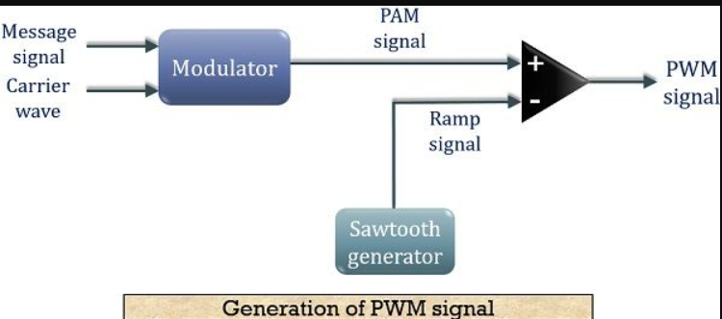

Fig.1: Block diagram of PWM signal

**PULSE POSITION MODULATION**

**Definition**:

A modulation technique that allows**variation in the position of the pulses** according to the amplitude of the sampled modulating signal is known as Pulse Position Modulation (PPM). It is another type of PTM, where the amplitude and width of the pulses are kept constant and only the position of the pulses is varied.

The information is transmitted with the varying position of the pulses in pulse position modulation. The basic idea about the generation of a PPM waveform is that here, as the amplitude of the message signal increases, the pulse shifts according to the reference.

As we have already discussed in PWM that due to the variable width of the pulses, the transmission power also varies accordingly. However, this is not the case with PPM as here the width of the pulses remains constant and only their position varies. Thus, transmission power does not show variation.

**Block diagram of PPM**

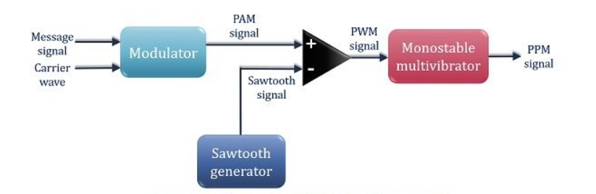

Fig.2 Block diagram of PPM signal

Here, we have made a detailed block diagram where first, a PAM signal is produced with is further processed at the comparator in order to generate a PWM signal.

The output of the comparator is fed to a monostable multivibrator. It is negative edge triggered. Hence, with the trailing edge of the PWM signal, the output of the monostable goes high. This is why a **pulse of PPM signal begins with the trailing edge of the PWM signal.**

It is to be noted in case of PPM that the duration for which the output will be high depends on the RC components of the multivibrator. This is the reason why a constant width pulse is obtained in case of the PPM signal.

With the modulating signal, the trailing edge of PWM signal shifts, thus with that shift, the PPM pulses shows shifts in its position.

**Duty Cycle:**

The term duty cycle describes the proportion of 'on' time to the regular interval or 'period' of time; a low duty cycle corresponds to low power, because the power is off for most of the time.

* Duty cycle is expressed in percent, 100% being fully on.
* The main advantage of PWM is that power loss in the switching devices is very low.
* When a switch is off there is practically no current, and when it is on, there is almost no voltage drop across the switch.
* Power loss, being the product of voltage and current, is thus in both cases close to zero.
* PWM also works well with digital controls, which, because of their on/off nature, can easily set the needed duty cycle
* PWM has also been used in certain communication systems where its duty cycle has been used to convey information over a communications channel.

The following figure shows the pulse at various duty cycles

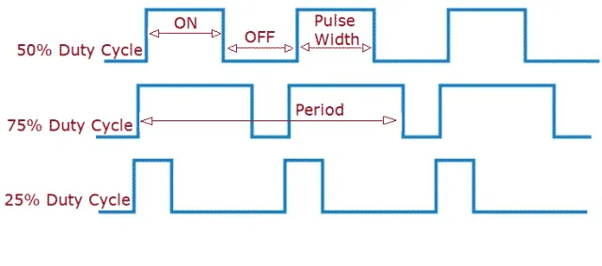

Fig 3. Various duty cycles

**SOFTWARE REQUIRED**

MATLAB Software

**About MATLAB software**

**MATLAB** (an abbreviation of "matrix laboratory") is a [proprietary](https://en.wikipedia.org/wiki/Proprietary_software) [multi-paradigm](https://en.wikipedia.org/wiki/Multi-paradigm_programming_language) [programming language](https://en.wikipedia.org/wiki/Programming_language) and [numeric computing](https://en.wikipedia.org/wiki/Numerical_analysis) environment developed by [MathWorks](https://en.wikipedia.org/wiki/MathWorks). MATLAB allows [matrix](https://en.wikipedia.org/wiki/Matrix_(mathematics)) manipulations, plotting of [functions](https://en.wikipedia.org/wiki/Function_(mathematics)) and data, implementation of [algorithms](https://en.wikipedia.org/wiki/Algorithm), creation of [user interfaces](https://en.wikipedia.org/wiki/User_interface), and interfacing with programs written in other languages.

Although MATLAB is intended primarily for numeric computing, an optional toolbox uses the [MuPAD](https://en.wikipedia.org/wiki/MuPAD) [symbolic engine](https://en.wikipedia.org/wiki/Computer_algebra_system) allowing access to [symbolic computing](https://en.wikipedia.org/wiki/Symbolic_computing) abilities. An additional package, [Simulink](https://en.wikipedia.org/wiki/Simulink), adds graphical multi-domain simulation and [model-based design](https://en.wikipedia.org/wiki/Model-based_design) for [dynamic](https://en.wikipedia.org/wiki/Dynamical_system) and [embedded systems](https://en.wikipedia.org/wiki/Embedded_system). As of 2020, MATLAB has more than 4 million users worldwide. MATLAB users come from various backgrounds of [engineering](https://en.wikipedia.org/wiki/Engineering), [science](https://en.wikipedia.org/wiki/Science), and [economics](https://en.wikipedia.org/wiki/Economics).

**Cleve Moler,** the chairman of the [computer science](https://en.wikipedia.org/wiki/Computer_science) department at the [University of New Mexico](https://en.wikipedia.org/wiki/University_of_New_Mexico), started developing MATLAB in the late 1970s. He designed it to give his students access to [LINPACK](https://en.wikipedia.org/wiki/LINPACK) and [EISPACK](https://en.wikipedia.org/wiki/EISPACK) without them having to learn [Fortran](https://en.wikipedia.org/wiki/Fortran). It soon spread to other universities and found a strong audience within the [applied mathematics](https://en.wikipedia.org/wiki/Applied_mathematics) community. [Jack Little](https://en.wikipedia.org/wiki/John_N._Little), an engineer, was exposed to it during a visit Moler made to [Stanford University](https://en.wikipedia.org/wiki/Stanford_University) in 1983. Recognizing its commercial potential, he joined with Moler and Steve Bangert. They rewrote MATLAB in [C](https://en.wikipedia.org/wiki/C_(programming_language)) and founded [MathWorks](https://en.wikipedia.org/wiki/MathWorks) in 1984 to continue its development. These rewritten libraries were known as JACKPAC. In 2000, MATLAB was rewritten to use a newer set of libraries for matrix manipulation, [LAPACK](https://en.wikipedia.org/wiki/LAPACK).

MATLAB was first adopted by researchers and practitioners in [control engineering](https://en.wikipedia.org/wiki/Control_engineering), Little's specialty, but quickly spread to many other domains. It is now also used in education, in particular the teaching of [linear algebra](https://en.wikipedia.org/wiki/Linear_algebra) and [numeric analysis](https://en.wikipedia.org/wiki/Numerical_analysis), and is popular among scientists involved in [image processing](https://en.wikipedia.org/wiki/Image_processing).

**MATLAB CODE**

**PWM Generation Code**

clc;

clear all;

close all;

t = 0:0.001:1;

fc = input ('Enter the Frequency of Carrier Signal (Sawtooth) = ');

fm = input ('Enter the Frequency of Message Signal (Sinusoidal) = ');

a = input ('Enter the Amplitude of Carrier Signal = ');

b = input ('Enter the Amplitude of Message Signal (should be < Carrier) = ');

vc = a.*sawtooth(2*pi*fc*t);

vm = b.*sin(2*pi*fm*t);

n = length(vc);

for i = 1:n

if (vm(i)>=vc(i))

pwm(i) = 1;

else

pwm(i) = 0;

end

end

subplot(3,1,1);

plot(t,vm,'black');

xlabel('Time ----->');

ylabel('Amplitude ----->');

title('Message Signal');

grid on;

subplot(3,1,2);

plot(t,vc);

xlabel('Sample ----->');

ylabel('Amplitude ----->');

title('Carrier Signal');

grid on;

subplot(3,1,3);

plot(t,pwm,'red’);

xlabel('Sample ----->');

ylabel('Amplitude ----->');

title('PWM Signal');

axis([0 1 0 2]);

grid on

**Code for PPM generation:**

clc

close all

clear all

fc=50;

fs=3000;

f1=200;

t=0:1/fs:((2/f1)-(1/fs));

x=0.4*cos(2*pi*f1*t)+0.5;

subplot(2,1,1);

plot(x);

title('message signal');

axis([10 30 0 1]);

grid on;

xlabel('time--->');

ylabel('amplitude--->');

y=modulate(x,fc,fs,'ppm');

subplot(2,1,2);

plot(y);

title('ppm signal');

axis([200 1700 0 1.2]);

grid on;

xlabel('time--->');

ylabel('amplitude--->');

**MODEL WAVEFORMS**

**PWM:**

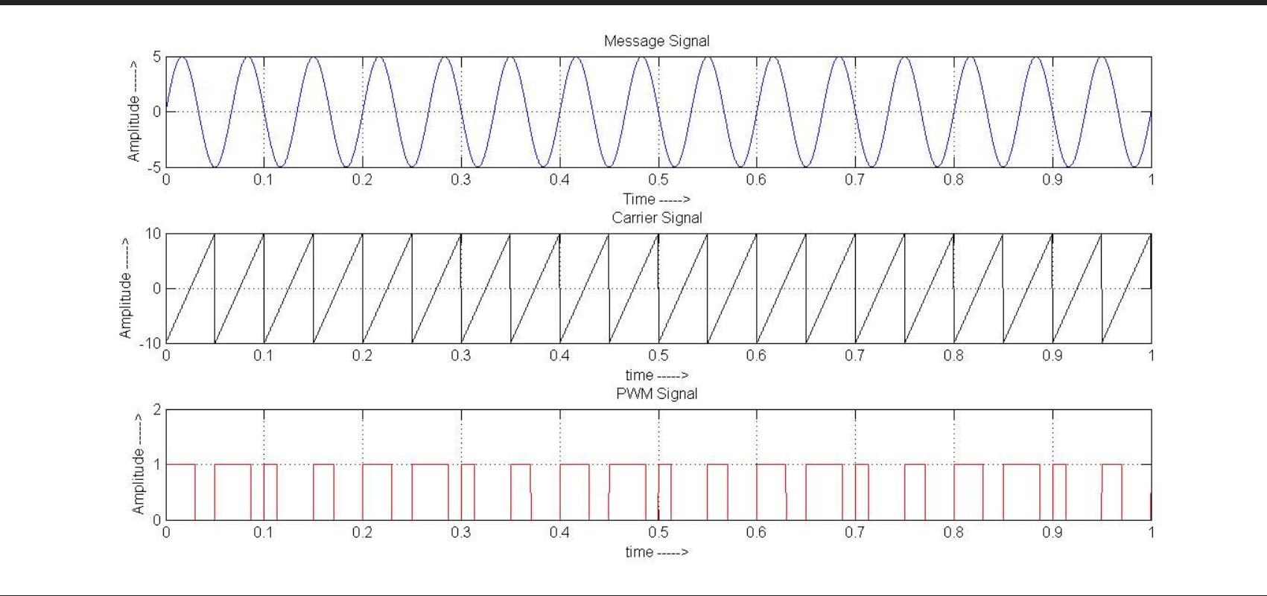

Fig 4. Model waveform of pwm

**PPM:**

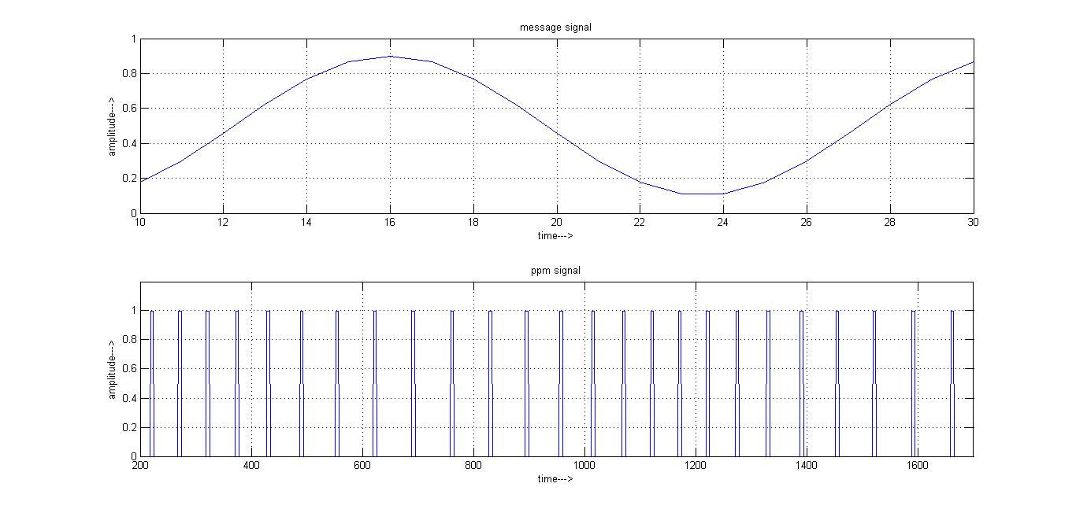

Fig 5. Model waveform of ppm

**ADVANTAGES**

**Advantages of PWM:**

* Noise interference is less or minimum.
* System is moderate in complexity to implement.
* It has moderate power efficiency among all three types.
* It supports higher power handling capability.

**Advantages of PPM:**

* Noise interference is less or minimum due to constant amplitude.
* It is easy to separate out signal from noisy signal.
* It has highest power efficiency and requires less power due to short duration pulses.

**DISADVANTAGES**

**Disadvantages of PWM:**

* Instantaneous power of transmitter varies.
* The system requires semiconductor devices with low turn-ON and turn-OFF times. Hence they are very expensive.
* High switching losses due to higher PWM frequency.

**Disadvantages of PPM:**

* It requires very large bandwidth compare to PAM.
* System is highest in complexity to implement.

**APPLICATIONS**

* PWM Techniques are used in Telecommunications for encoding purposes.
* Pulse Width Modulation helps in voltage regulation and thus finds its use in controlling Brightness in Smart Lighting Systems and also controls the speed of motors.
* PPM techniques are used in radio frequency (RF) communication. Also used in contactless smart card, high frequency, RFID (radio frequency ID) tags and etc.

**OUTPUT WAVEFORMS**

**PWM:**

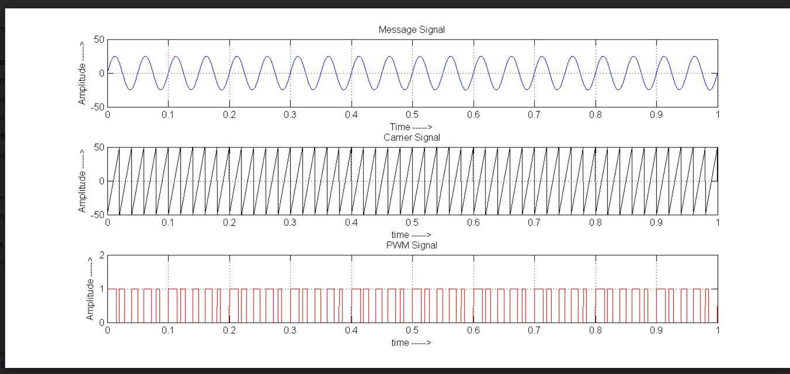

Fig 6. Output waveform of PWM

**PPM:**

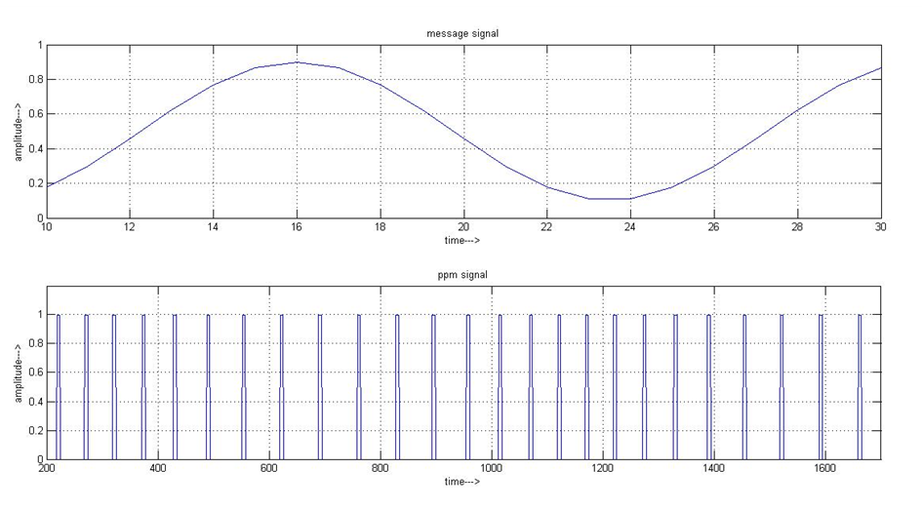

Fig 7. Output waveform of ppm

**CONCLUSION**

The generation of pulse width modulation and pulse position modulation signals are done using MATLAB software. The output waveforms of the pulse width modulation and the pulse position modulation are observed. Hence the pulse width of the carrier varies with respect to message signal for pulse width modulation and the pulse position of the carrier varies with respect to message signal for the pulse position modulation.

**REFERENCES**

* <https://in.mathworks.com/matlabcentral/answers/13934-how-can-i-generate-ppm-pam-pwm-modulation-and-demodulation><https://www.slideshare.net/raviteja05/ac-matlab-programs-14836494>
* <https://www.slideshare.net/raviteja05/ac-matlab-programs-14836494>
* <https://en.wikipedia.org/wiki/PAM>
* [https://en.wikipedia.org/wiki/Pulse-position_modulation#:~:text=Pulse%2Dposition%20modulation%20(PPM),bits%20per%20second](https://en.wikipedia.org/wiki/Pulse-position_modulation)